CIS 424 Documentation –
Font/Size Standards for Documents

Development- (example on page 2)
- Follow standards based on the appropriate group.
  - Font Type:
    - Calibri Light (Heading) for Title
    - Calibri for Body
  - Font Size:
    - 16 pt for Title
    - 11 pt for Body
  - Spacing:
    - 1.5 for Body

Quality Assurance-(example on page 3)
- Follow standards based on the appropriate group.
  - Font Type:
    - Calibri Light (Heading) for Title
    - Calibri for Body
  - Font Size:
    - 16 pt for Title
    - 11 pt for Body
  - Spacing:
    - 1.5 for Body

Documentation-(example on page 5)
- Follow standards based on the appropriate group.
  - Font Type:
    - Calibri Light (Heading) for Title
    - Calibri for Body
  - Font Size:
    - 16 pt for Title
    - 11 pt for Body
  - Spacing:
    - 1.5 for Body

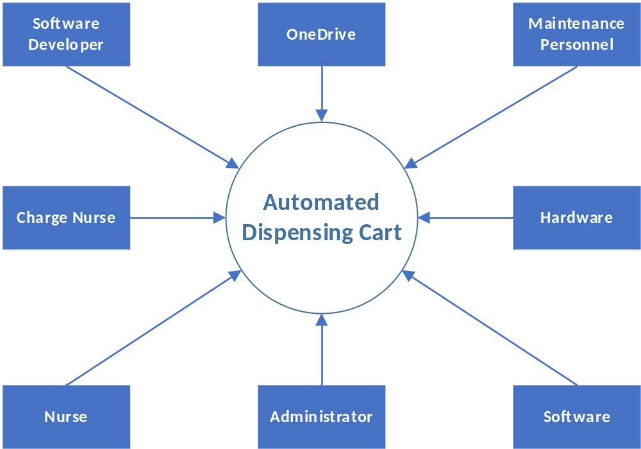System Context Diagram

Evaluation Procedures for Project issues as 01/24/2021
(1) A QA evaluator will evaluate his/her assigned system with test cases and sample data.

(2) For each discovered issue, the QA evaluator will start and maintain an Issue Record
Form in Word. The top section of the form will act as a standard template for
a discussion board topic.

(3) A new topic concerning the issue will be posted in the QA discussion area.

(4) All fields (except internal QA commentary) are to be posted as a new topic,
where the topic’s subject is in the following format:

Issue Code###, Build: ID, By Evaluator, RE: Short Description

Examples: Issue WEB001, Build: 45, By: Smith, RE: Missing Submit Button
Issue DBS041, Build 12, By: Jones, RE: Blue Screen on Sort

All issue numbers should use 3 numerals (using leading zeroes as needed).
The system codes are as follows:

DBS Radiator/Quotation System Database
WEB Web Interface
SEC Security and Networking
(5) Each QA evaluator will check their topics’ threads and post responses to the topics until
the issue is resolved. Communication should be performed through topics instead
of emails to maintain a running record for all groups and group members. However,
emails may be needed if other group members are not checking or replying to the topics
as expected. These emails should be directed to the QA Leader who will forward the
concern to the Group Leader of the appropriate group.

Office 2019 Activation Instructions
- Depending on your browser, select Run (in Edge or Internet Explorer), Setup (in Chrome), or Save File (in Firefox).
If you see the User Account Control prompt that says, Do you want to allow this app to make changes to your device? select Yes.
The install begins.
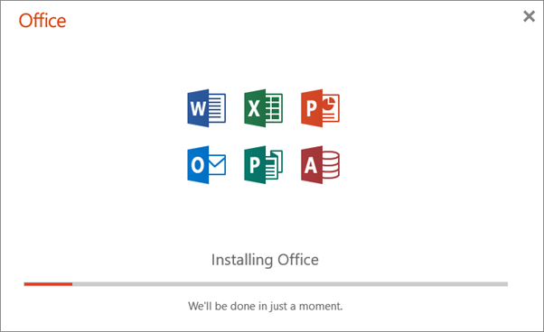
- Your install is finished when you see the phrase, "You're all set! Office is installed now" and an animation plays to show you where to find Office applications on your computer. Select Close.
